**Eco-sip**

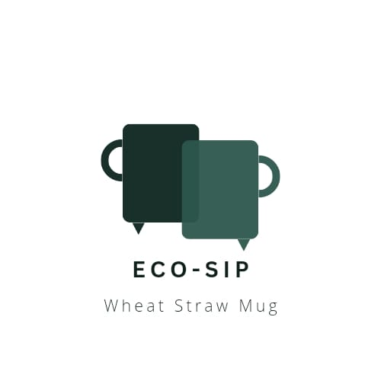

**Introduction:** Our wheat straw mug is a sustainable and eco-friendly alternative to traditional mugs. It is made from natural wheat straw fibers, which are a byproduct of wheat production, making it a renewable and biodegradable material. The mug features a sleek and ergonomic design that fits comfortably in your hand.

**Description:** One of the unique features of our wheat straw mug is its thermal insulation properties, keeping your hot beverages hot and cold beverages cold for longer periods. The natural wheat straw material provides a natural barrier to heat transfer, reducing the need for disposable sleeves or double-walled designs.

In addition to its environmental benefits, the wheat straw mug is also durable and lightweight, making it perfect for everyday use at home, in the office, or on the go. It is easy to clean and dishwasher-safe and it does not retain odors or flavors from previous beverages, ensuring a fresh taste every time.

By choosing our wheat straw mug, you are not only reducing your carbon footprint but also supporting sustainable farming practices and contributing to a greener planet. Enjoy your favorite beverages while making a positive impact on the environment.

|  |  |  |  |
| --- | --- | --- | --- |
| **Brand** | **Size** | **Price** | **Availability** |
| Eco cup | 12 oz | $10 | In stock |
| Natural Mug | 16 oz | $12 | Out of stock |
| Greenway | 14 oz | $8 | In stock |

**Sustainability:** Our wheat straw mug is a highly sustainable and eco-friendly choice for your beverage needs. It is crafted from natural wheat straw fibers, which are a renewable resource and a byproduct of wheat production. By utilizing this material, we contribute to reducing waste and the overall carbon footprint associated with traditional plastic or ceramic mugs.

**Facebook:** <https://www.facebook.com/profile.php?id=100086747372223&mibextid=ZbWKwL>

**Instagram:**

<https://instagram.com/eco_sipp?igshid=MzRlODBiNWFlZA>==